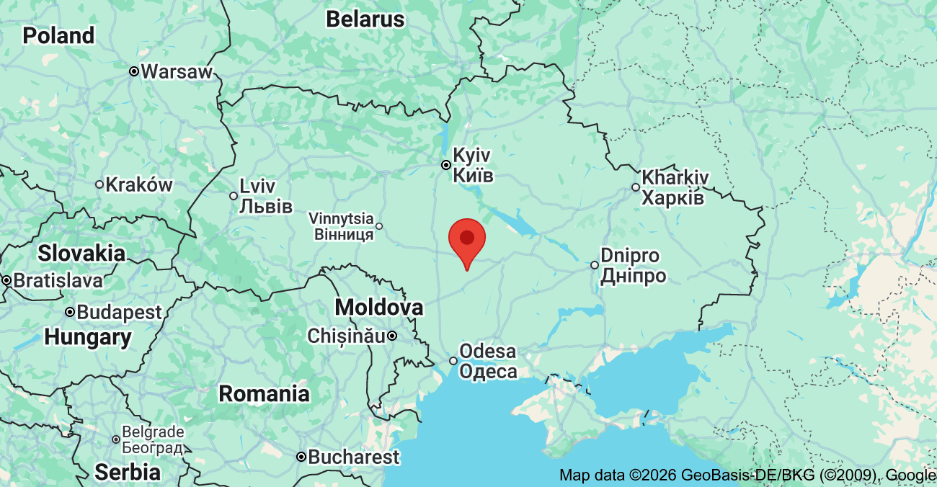
Yiddish Book Group (Sponsored by the NCPL and the Yiddish Book Center)
Thursday, June 11, 2026 4PM-5:15PM
Tevye the Dairyman (Penguin, 2009) by Sholem Aleichem (Rabinovitch)
Prepared by Dr. Cynthia Kreisel

A bit about the author, Sholem Aleichem (Rabinovitch):
- Sholem (1859-1916) was born in the Peryeslav region of the Ukraine, 95 km down-
river from Kiev (Kyiv).
- Sholem Aleichem, the supposed author, is actually a character himself in the book—a “chatty, omniscient narrator.”
- Early in his career Sholem Aleichem criticized what he called Yiddish “trash” literature, but he ended his life as the most popular Yiddish writer of all time.
- He moved to New York at the beginning of WWI in order to escape hostilities in Germany and continue his writing.

- Sholem believed that the new American Jewish Community was resourceful, politically strong, with a unique culture and an important role to play in the affairs of Jews in around the world. (Tevye, 2009, introduction, ix-xii).

Other works by Rabinovitch:
- Motl, the Cantor’s Son [Motl, Peyse dem Khazns] c. 1905

OPENING QUESTIONS:
- What were your expectations going into this book? What surprised you? Did it feel more like storytelling, history, or cultural commentary?

- At the peak of his career, Sholem Aleichem abandoned writing in the classic novelistic style, instead setting himself up as an “omnipresent interlocuter.” The characters in the book, then try to impress, influence, or attack the author himself who is part of the story as an observer and interviewer.
How did you find this writing style? Was it understandable? Confusing? Enjoyable?
What are the benefits of telling a story in this manner? Problems?
(PART I)
Questions adapted from Ruth Wisse, “Ruth Wisse Teaches Sholem Aleichem’s Tevye the Dairyman: A Study Guide,” The Tikvah Fund (2019): 4-19.
- In what ways is Tevye different from the average shtetl* (city) Jew? What qualms with the shtetl lifestyle might have caused Sholem Aleichem to write Tevye this way? In what ways might Tevye’s breaks with the traditional life be a reflection of SA’s proto-Zionism? (* indicates a term in the glossary.)
- Tevye’s liberal use of biblical quotations often leads him to take words out of context or misapply them. Is he a hapless fool or a knowing comedian? Do you think that we are supposed to laugh at or laugh with Tevye? Why?

(PART II)
- Is this story simply a critique of Menachem Mendl’s reckless optimism, or does it imply that Tevye needs to balance some of his traits with Menachem Mendl’s?
(PART III)
- Parts II and III were published in Der Yid, a Zionist weekly. What Zionist* themes does this story contain?
- When Tsaytl broaches the subject of her marriage with her father, she does it with affection and sorrow, rather than anger or distance. Were you surprised at the closeness between Tevye and his daughters? Do you think that this closeness was typical between a daughter and father in pre-revolutionary Russia? Why or why not?
- The story ends on a hopeful note, but it is clear that there is some tension between Tevye’s way of life and the life his daughters want. What does the younger generation want that their elders might be unprepared to give?
(PART IV)
- Hodl is, in some ways, a product of modernity: she is a bookworm and an intellectual and is attracted to Pertchik’s revolutionary mindset. But by leaving her family and committing to her husband, Hodl is actually following tradition. Should we celebrate Hodl for breaking the mold or for her ultimate embrace of tradition?
- This ending is the most tragic thus far, and it comes as a direct result of political conflict and revolution. What message about revolution is Sholem Aleichem trying to send with this story?
(PART V)
- Why do you think that, unlike her sisters, Chava cannot reconcile with her father at the end of the story?
- Does the “spirit of love and universal brotherhood” that we strive for in modern, liberal societies make intermarriage (religion, race, class) a more valid choice? Why or why not?
(PART VI)
- What do you think about the theory that Shprintze’s depression is cause by her out-of-wedlock pregnancy? If Shprintze is not pregnant, what do you think leads her to take her own life? Do you agree with the Freudian interpretation* that Shprintze is acting on Tevye’s unconscious wishes?
- In a sense, it is Arnold’s inability to stand up to his family that leads to Shprintze’s suicide. In what way is Sholem Aleichem criticizing the young, irresponsible Jew in this story? Why might this criticism have been particularly relevant in his time and how is it relevant today?
(PART VII)
- Beilke asks not to be compared to her sister Hodl, who abandoned her father to follow her revolutionary husband. Which daughter’s path is more praiseworthy? Should we applaud Beilke for her devotion to her father and willingness to marry someone she does not love in order to take care of Tevye’s material needs? Or should we admire Hodl for her devotion to a cause that is greater than her family?
- Did Beilke make the right choice in marrying and staying with Podhotzur? Why or why not? If not, is Tevye to blame for raising her to value the material over the spiritual or traditional?
(Part VIII)
- “Lekh-Lekho” is taken from the Torah* portion that describes God’s commandment to Abraham to leave his birthplace and go to the land of Israel. In what ways does Tevye’s story fit this positive archetype and in what ways doe Tevye’s story subvert it?
- Why do you think Sholem Aleichem, a Zionist, ended Tevye’s story this way, rather than allowing him to complete his journey to Palestine?
- Do you think Tevye is a good father? Why or why not?
CLOSING QUESTIONS:
- Do any of Tevye’s or his daughters’ struggles apply to the modern world (e.g. his jilted daughter, the tension between rural and urban populations, misunderstandings between different generations, or the dream of a Jewish homeland in Palestine)? Explain.

- Looking back at Tevye’s stories, how do you think Tevye’s journey was influenced by current events in Sholem Aleichem’s time? Would Tevye’s tale have ended differently if Sholem Aleichem were writing today? What might that ending have looked like?

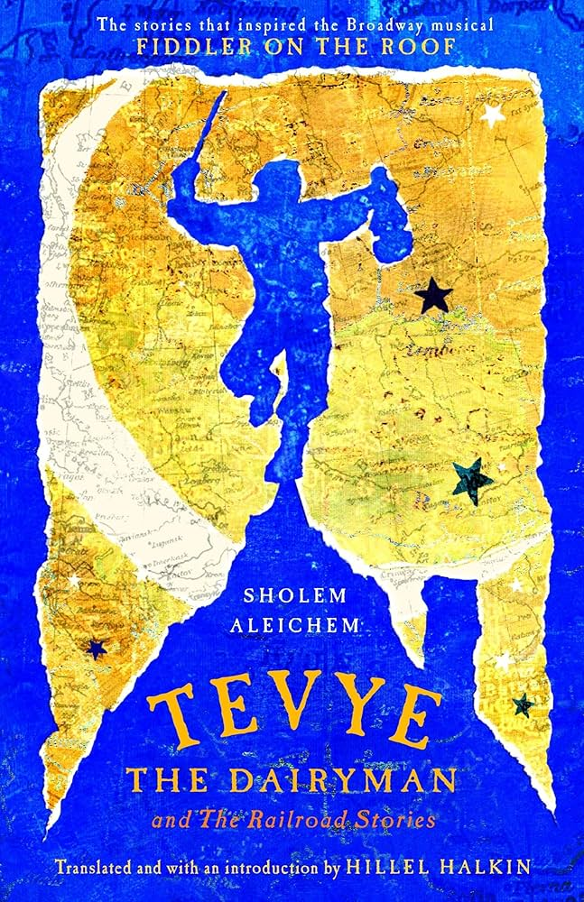

GLOSSARY (Yiddish and English words):  Eastern European Jewry in the early 20th c: Violence against Jews in eastern Europe was escalating. Pogroms led to a large population of Jewish refugees, many of whom attempted to flee from Russia to New York.  Freudianism: Sigmund Freud proposed that humans were led primarily by unconscious desires, rather than the ego (our conscious self).  Pogrom: A state-sanctioned violent action against individuals because of their ethnic makeup.  Russian Revolution: Two revolutions occurred in Russia in 1917, the first of which overthrew the Czar. The second revolution, a civil war against the Whites and the Reds (Bolsheviks), placed the Bolsheviks in power.  Shtetl: city/ town/ urban  Torah: The first five books of the Hebrew Bible (basic). More broadly, it represents God’s divine revelation to Israel.  Zionism: Jewish nationalist movement with the goal of the establishment and support of a Jewish state in Palestine. | 